Hacker earth questions solved by Kunjal Rathore ~25csu123
Q1-
You are given a table with n rows and m columns. Each cell is colored with white or black. Considering the shapes created by black cells, what is the maximum border of these shapes? Border of a shape means the maximum number of consecutive black cells in any row or column without any white cell in between.
A shape is a set of connected cells. Two cells are connected if they share an edge. Note that no shape has a hole in it.
Ans1-
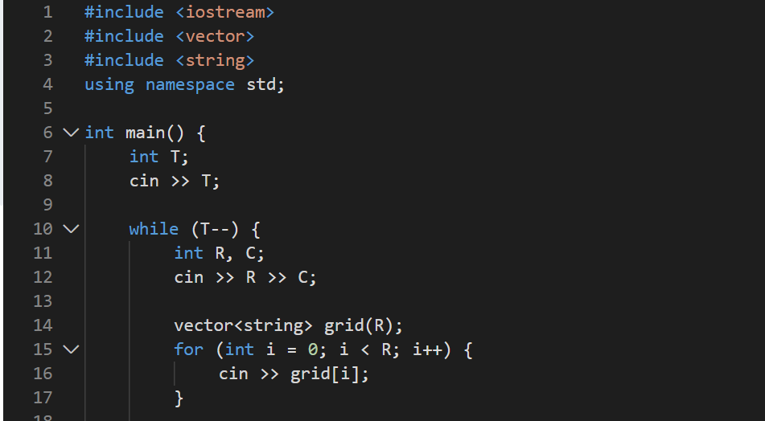
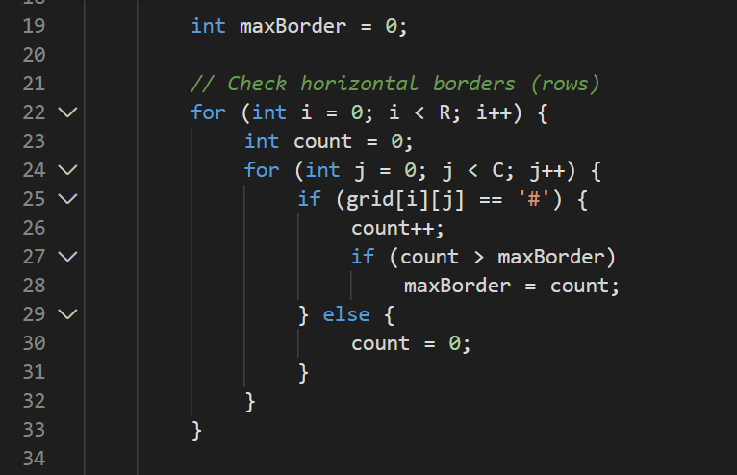

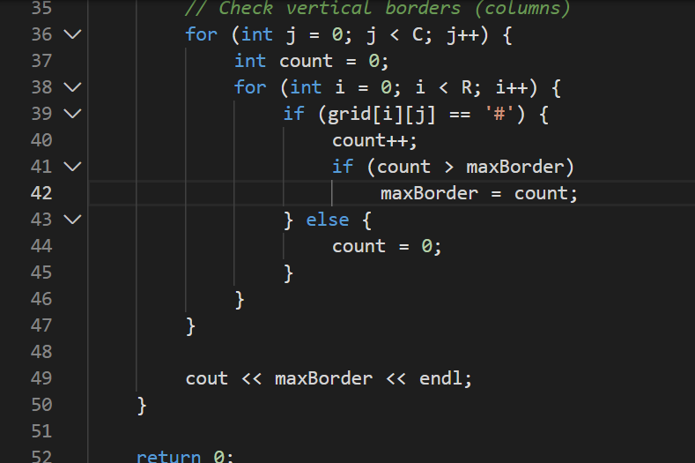
Q2-
Bob has a playlist of N songs, each song has a singer associated with it (denoted by an integer)
Favourite singer of Bob is the one whose songs are the most on the playlist
Count the number of Favourite Singers of Bob
Ans2-
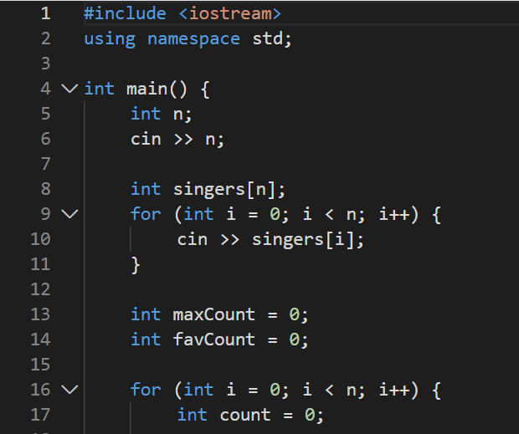
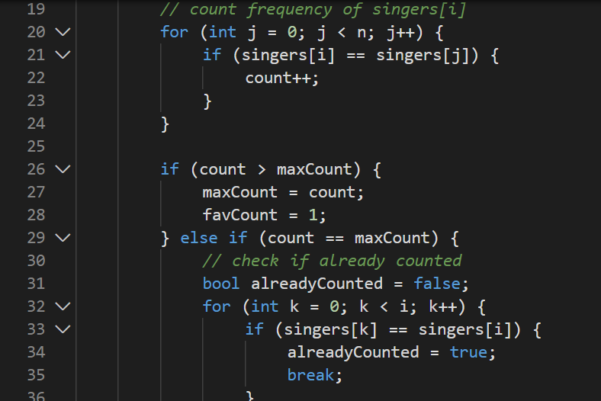
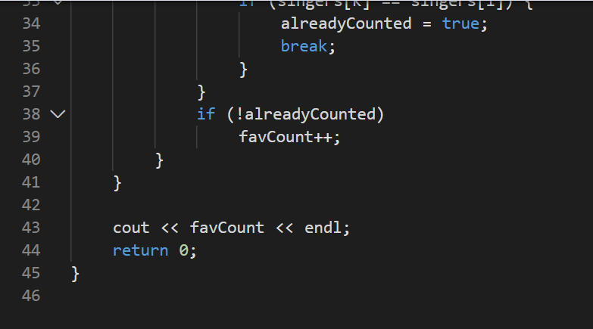
Q3-
You are required to enter a word that consists of x and y that denote the
number of Zs and Os respectively. The input word is considered similar
to word zoo if 2 x x = y.

Determine if the entered word is similar to word zoo.

For example, words such as zzoooo and zzzoo000o are similar
to word zoo but not the words such as zzooo and zzzo0000.
Ans3-
